# Research Proposal ME44312

## EV Charging Group 4

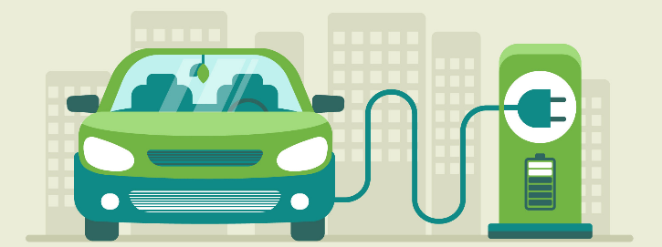

Thijs Daemen – 528949, Alene Hooiveld – 5310539, Chris Juárez – 5171806,

Mathijs Markus – 5405416 and Niels van der Rijst – 5380162

Date: March 5, 2025

### Dataset

The dataset that will be analysed in this research is the Adaptive Charging Network (ACN) dataset, which is publicly available online thanks to Lee, Li, & Low (2019). This dataset captures detailed information about electric vehicle (EV) charging sessions at stations at Caltech University (US) and JPL research lab (Canada). Each record represents a single charging session and includes timestamps, energy delivered, user inputs, and site information. This dataset was chosen because of the increasing relevancy of EV’s and the corresponding charging capacity problems. As the power grid in The Netherlands is very full, it is also rather interesting to see how the combination of low grid capacity and the use of charging stations can be optimized.

### Research questions

Main research question:

How can the peak power demand at EV charging stations be reduced by predicting vehicle dwell time?

Sub-questions:

1. What is the current state in literature of the application of machine learning techniques in EV charging data.
2. How can the vehicle dwell time at EV charging stations be predicted by applying Machine learning techniques on historical EV charging data.
3. To what extent can the predicted vehicle dwell time improve load management strategies at EV charging stations.

### Methods

The first sub-question will be addressed through a literature review of studies that apply neural networks to predict vehicle dwell time or similar processes. This will help determine the best approach for developing a neural network model using available data, such as arrival time and requested energy.

To answer the second sub-question, a neural network model will be developed and trained on historical charging session data to predict dwell times. The model’s accuracy will be evaluated by comparing predicted and actual dwell times.

The third sub-question will be answered by using these predicted dwell times to design a load management strategy aimed at reducing peak power demand. For example, by shifting or distributing charging loads more efficiently.

The main research question will be answered by combining the findings from the literature review, prediction model, and load management strategy.

### Experiments

During the analysis, the neural network model will be evaluated, i.e. the model fit will be checked and also compared with the outcomes of similar studies. Should the model fit be too low, then the model can be adapted by for instance changing the hyperparameters used in the training of the model.

### References

Lee, Z. J., Li, T., & Low, S. H. (2019, June). ACN-Data: Analysis and applications of an open EV charging dataset. *Proceedings of the Tenth International Conference on Future Energy Systems (e-Energy '19)*, Phoenix, Arizona. Association for Computing Machinery.

1. Data analyse, in order to understanding the main correlations, patterns in the data.
2. Linear regression as benchmark model
3. (various) neural networks as model
4. Happy end